**My Address Book**

**Report**

CSC 1103

OBJECT ORIENTED PROGRAMMING

Semester 1 2018/2019

**Section 2**

Supervised by

**ALI A. ALWAN ALJUBOORI**

Maimul Hoque (1726537)

Jaki Fayek Alvi Rahman (1721485)

Sultan Syafriyudi (1721899)

Mohammad Tahmid Lodi (1725491)

**Table of Content**

**1.** **Project Description 2**

**2.** **Project Organization 2**

**3.** **Methodology 3**

**3.1.** **Analysis 3**

**3.2.** **Design** **4**

**3.3 GUI Screenshot 5-14**

**3.4****UML Diagram** **15**

**3.5** **Gantt Chart 16**

**4. List of constraints and challenges faced 16**

**5****.** **Conclusion 16**

**6. Task distribution 16**

# Project Description

My Address Book is a desktop application created for the purpose of keeping track of user contact list and details about them. A user can add, delete and update contact. It has multiple user option consisting of different data set for different user. It also has the real time search option and instant login logout option. Finally user can sign up or reset forgotten password by using pin code entered at sign up time.

# Project Organization

# 

# Methodology

## Analysis

The Functional requirements of our project are:

1. User have to valid their data themselves.
2. User must have to limit their contact list to 1000 and accounts to 5 only
3. User cannot change password without valid pin number
4. No space is allowed in user name or password
5. ‘|’ character in creating contact will cause the program to give unexpected result

## Design

* Our program use text file to store credential and contact list in separate file
  1. **GUI Screen shot**

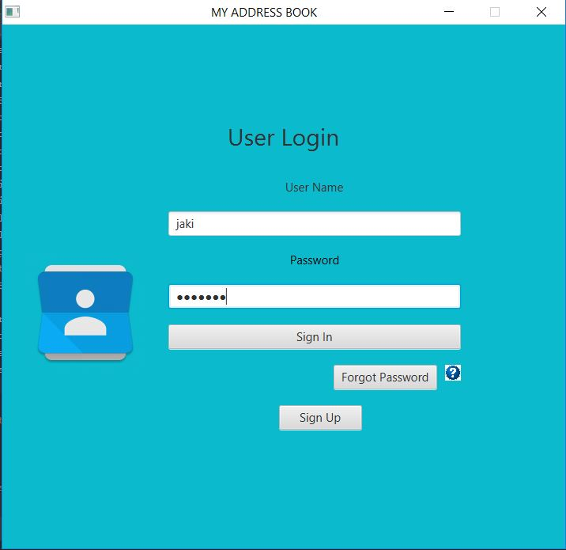

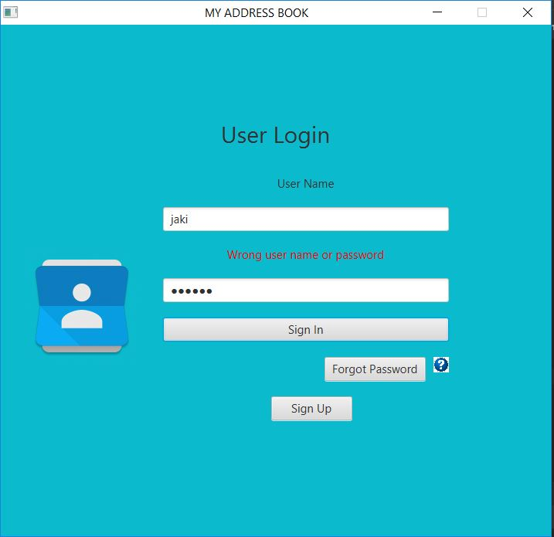

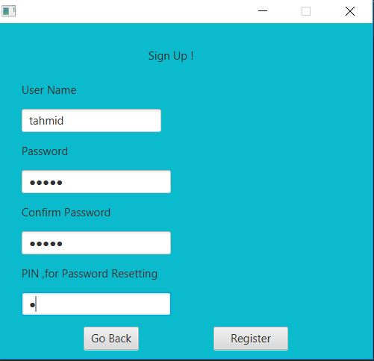

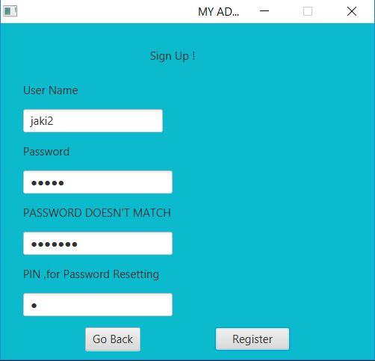

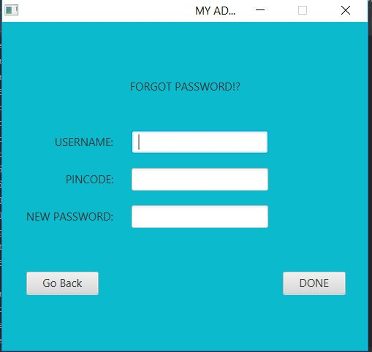

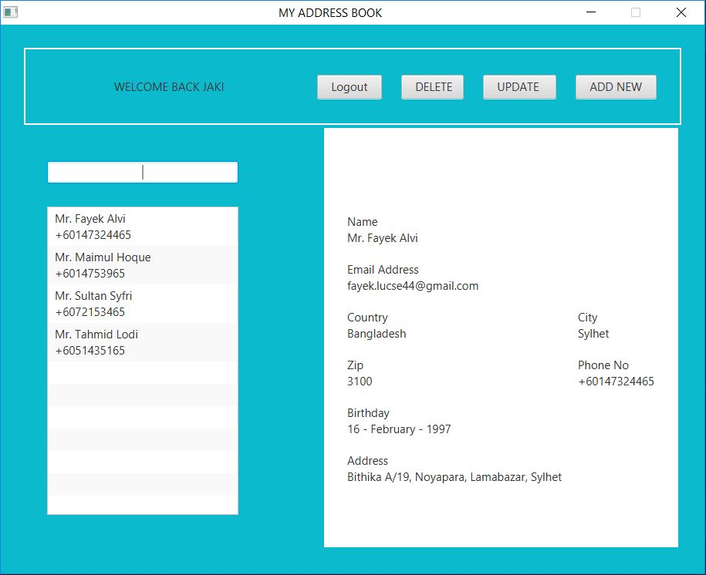

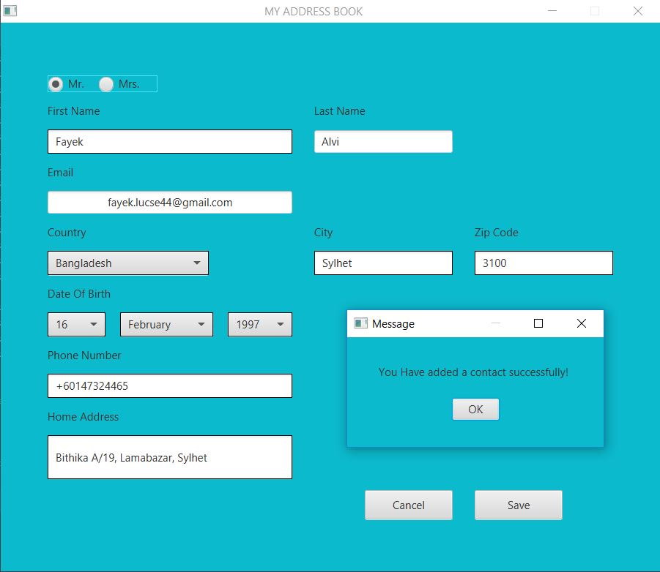

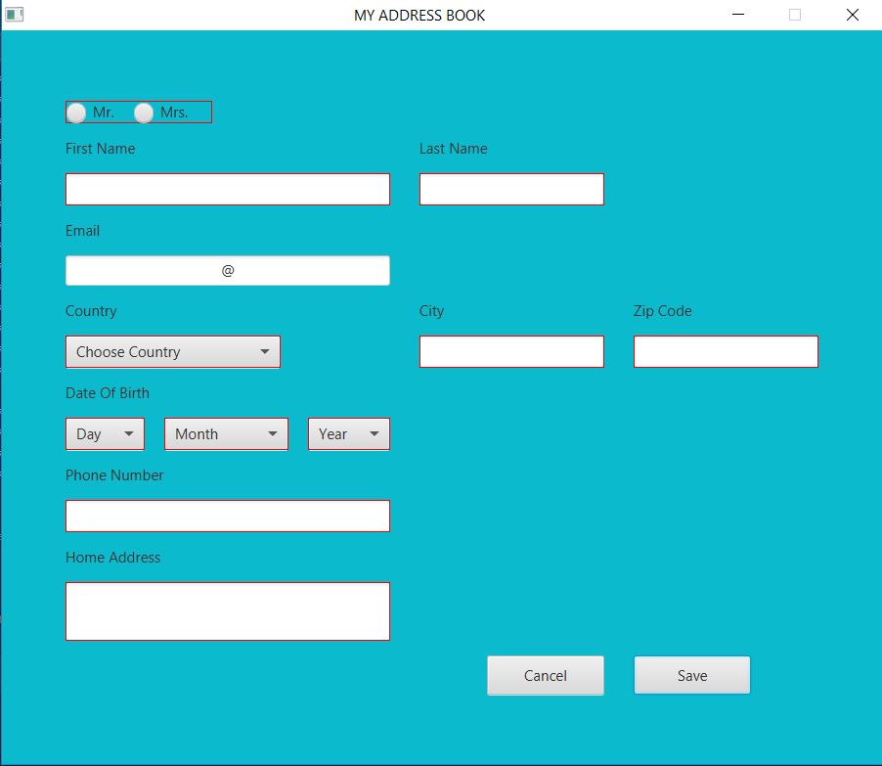

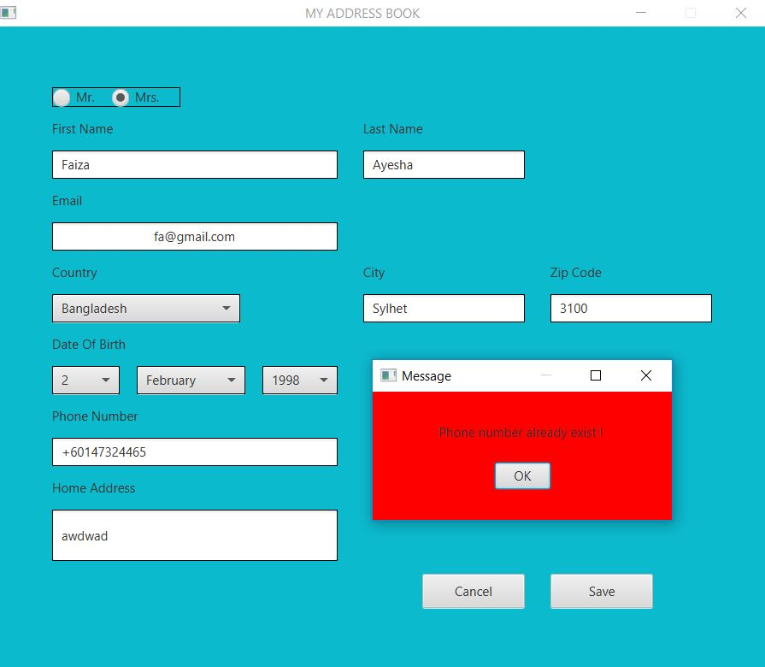

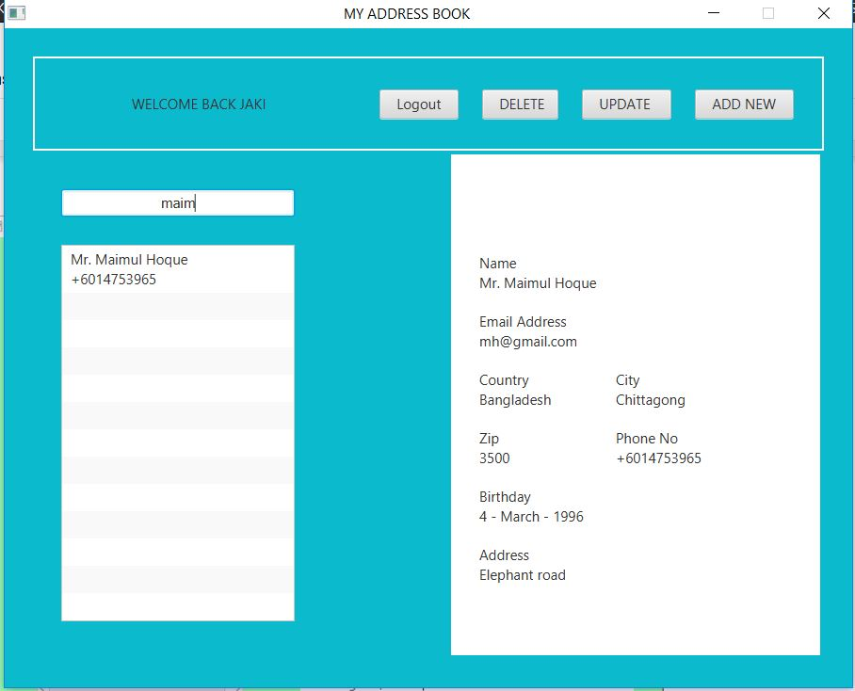

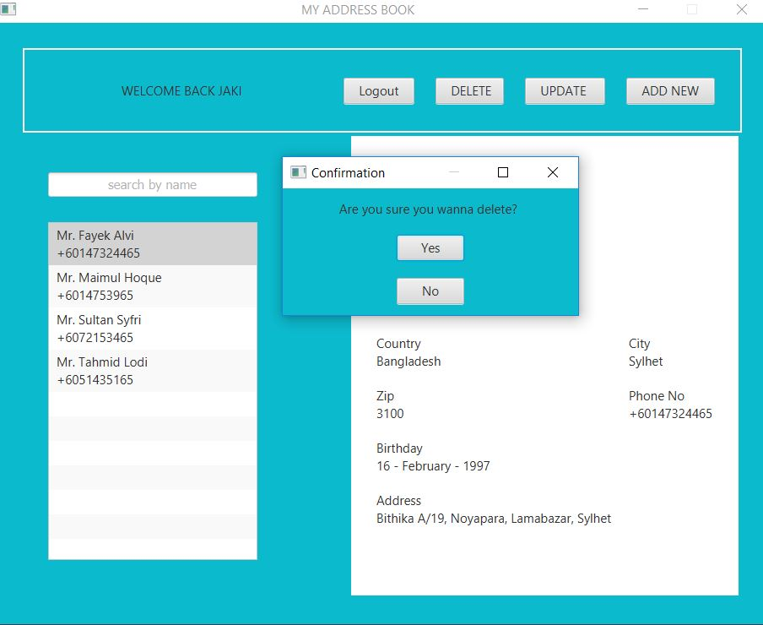

**3.4 Class Diagram and UML**

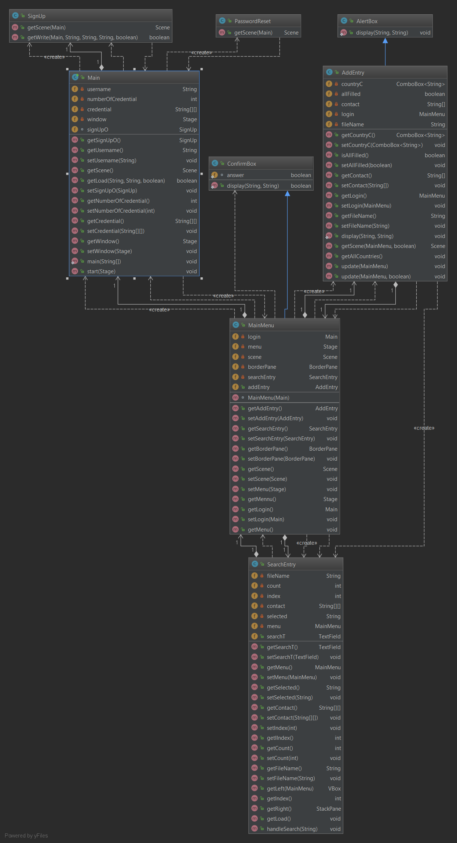

**3.5 Gantt Chart**

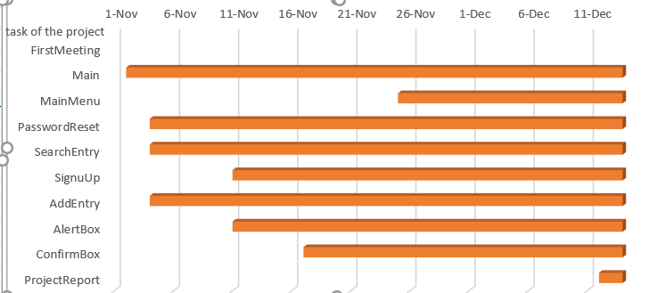

# List of constraints and challenges faced

* We tried to use filereader and filewriter to store data of users and contacts. When we tried to use class inheritance instead of file, the program was not running properly.

# Conclusion

# As a future improvement, we want add the following features:

* Cloud back up service
* Image attribute for contact list
* Portability
* Instant call or chat system by sending command to phone

**6. Task Distribution**

|  |  |
| --- | --- |
| **task number:** | **Member** |
| 1. **Main** | **Mohammad Tahmid Lodi 1725491** |
| **2. MainMenu** | **Mohammad Tahmid Lodi 1725491** |
| **3. AlertBox** | **Jaki Fayek Alvi Rahman (1721485)** |
| **4. ConfirmBox** | **Maimul Hoque (1726537)** |
| **5. PasswordReset** | **Maimul Hoque (1726537)** |
| **6. SearchEntry** | **Sultan Syafriyudi (1721899)** |
| **7. SignUp** | **Sultan Syafriyudi (1721899)** |
| **8. AddEntry** | **Jaki Fayek Alvi Rahman (1721485)** |
| **9. Project Report** | **Jaki Fayek Alvi Rahman (1721485)**  **Mohammad Tahmid Lodi 1725491** |